1. **How to use air bounce playground**

**I want to share with you how to base your mission on the tent makers mission.**

**It is a safe air bounce playground that gives dreams and hopes to children who do not have a playground in a poor country and gives them an opportunity to meet with the Lord.**

**So far we have sent over 60 bounce house playgrounds to 35 countries in 10 countries (China, Mongolia, USA, Mexico, Thailand, Cambodia, Vietnam, Philippines, Tanzania and Guatemala).**

**Through this, many young souls were able to experience the return to Jesus.**

**After receiving the bounce house, missionaries from around the country first lie around 2 or 4 places around the church and travel by car**

**Where there is no church, it becomes the prime for the establishment of a church through young children.**

**After the children first line up, they pray together for a minute and then they start playing.**

**I like to play praise or shake to the children and let them play with bubble balloon machines.**

**I will make an appointment with the children at what time next week. Prepare the children's scripture verses and share them with us. You can see all the children recite the Bible when you meet after you make an appointment.**

**Praise and encourage children who are prepared to carry sweets or small bread and carry it on their hands will be the basis for the church building in the area**

**If there is a missionary who needs Air bounce playground, please contact me.**

[**myungjinsik@gmail.com**](mailto:myungjinsik@gmail.com) **tentmakermission@gmail.com**

**kakaotalk ID: us7890 USA Phone 213-503-0787**

**Keep your pictures and videos of children in the air bounce playground when you enter the country and use it well.**

**It is helpful when you meet with the city hall or government official (Ministry of Education) where missionaries are staying. "We need a place for public playgrounds in the area," he said, suggesting that they provide a playground and a children's library where children can play around if they provide a place. If you get permission, we will arrange a prefabricated playground and library fixtures to be installed at our park in TENT MAKERS MISSION.**

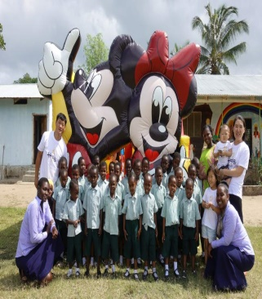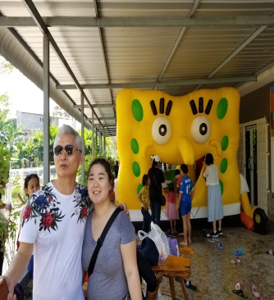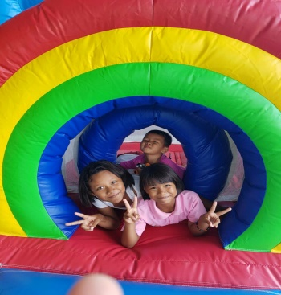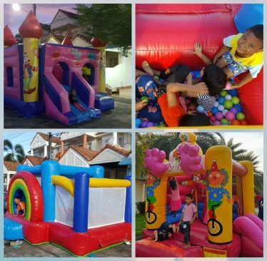

1. **Local Scholarship Program**

**The scholarship project is designed to help the missionaries of each mission place around the church (children who do not believe in Jesus, Islam, religion ...) to select children with difficulties in life, help them to come to church, That is the purpose. ,**

**1. Supports children such as orphans and parents.**

**2. We make a bankbook in the name of each child and entrust it to the school homeroom teacher.**

**(The missionary or guardian is not allowed to use it arbitrarily, so that the relationship of submission of gold is not established.**

**3. If the grade falls, cancel the scholarship support. (The missionary confirms the report card twice a year or more (once every six months) and sends the photo to the sponsor.**

**4. Every month, teachers pay scholarships through donation ceremonies where students see. (I can pay it by bankbook or deliver it myself. I know I am not alone.**

**5. You must attend the church every Sunday (it is also the purpose of your relationship with Jesus and the scholarship project).**

**6. Maintain spiritual and spiritual mentor relationships between sponsors and scholars.**

**7. Scholarships are awarded on a yearly basis and will be rescheduled once a year or not**

**The TENT MAKERS MISSION Mission will pay for the remittance costs of all other relief organizations (World **, etc.), but only 40% of the actual amount will be paid for the benefit of the applicant. Supported.)**

**Individual scholarship ministry can be developed into next school ministry**

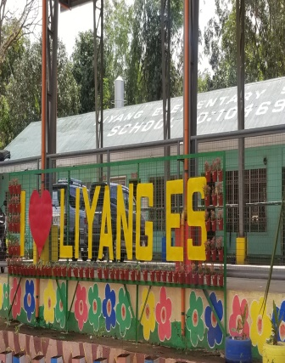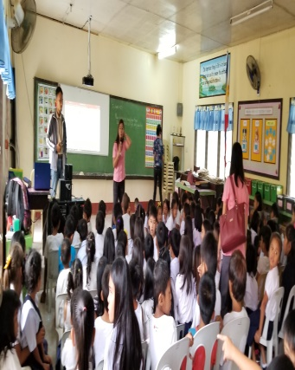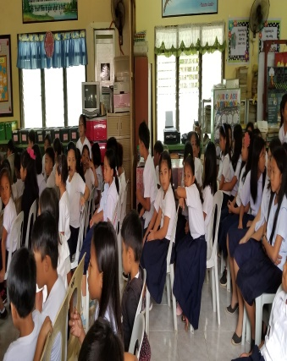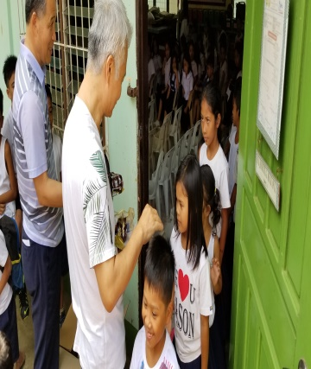

**3. Students Mission Strategies School Ministry Scholarship**

**1. Find a rural school that is about 4 hours away from the city (there are local differences).**

**2. Students are recommended to the school principal from 50 to 60 students who are raised in grandmother hands without a parent or mother, regardless of religion or school records. A missionary and a local church pastor visit the children's house together. The reason is to look at the lives of children directly and to support children who really need scholarship support. If you do, you can hear a detailed story about the child from this neighbor. After confirming the financial status and family relationship of the students who support the preliminary scholarship, we will select about half of the 50 ~ 60 students.**

**3. We look for a lady who can give lunch and lunch to 30 scholarship members in the family of faith or sincere people**

**4. Lunch every day with a class (usually you will need to help your children lunch with lunch). We will serve lunch with rice, meat, fish, vegetables, etc. We usually expect to spend about $ 30 a month at a price of about $ 1 a day.)**

**5. If you are seated after 2 ~ 3 months, consult with the principal. I would like you to have a time to meet all the students once a week. Usually one hour will be given, and at that time, all the students will be able to gather the Bible to all students through local pastors and evangelists. Praise, rhyme, and recitation of the Bible. We also distribute snacks.**

**How to use 1 hour**

**1) Praise and rhythm time**

**2) Tell the story of the Bible (comic, puppet show, storytelling) and ask the student again the character or story of the story of this week's story, and present a cake if you answer the correct answer.**

**4) The whole student finishes the episode with prayer after the last praise. Provide children with snacks and bless them at the entrance. (Promoting community consciousness)**

**Average budget**

**One meal for 20 days Uses 20 for the whole month 1 for 1 dollar For the remaining 10 dollars, 10 dollars will be used for uniforms, notebooks, bags and so on.**

**Kitchen 4,000 pesos ($ 80) Electricity cost 2,000 pesos ($ 40)**

**A total of $ 30 * 30 people = $ 900 is needed every month. Total 1100 ~ 1200**

**The remaining amount will help you with school uniforms, school supplies, bags, etc.**

**After two or three years, all upper secondary schools will be filled with scholarship children)**

**Donors and recipients of scholarships**

**Every month, more than once a month, they communicate with each other in any way (such as video, messenger, etc.).**

**It is not only a financial sponsor, but also a spiritual mother and father.**

**If possible, visit the mission field once a year and allow the beneficiary to spend more than one day together.**

1. **College ministry**

**1. Dormitory resolution**

**1) When rural children who graduated from high school in the country of each mission field enter the university as a city, dormitory is required. TENT MAKERS MISSION Due to the provision of local dormitory in the missionary, the missionary teaches Korean language study on Wednesday and the local minister comes on Friday to study Bible. Sunday is to attend the church and serve the church, and after graduating from college, it is the goal of raising it to be the church leader of the country. First, students volunteer to organize their students and prepare their dormitories. Never build a building first.**

**2) The goal is to create a leader of faith and to become a future Christian leader.**

**3) It operates autonomously and charges electricity and water charges. Set up a leader to resolve the schedule.**

**4) It is not the purpose of adults to lead children, but to set the dormitory rules and students to voluntarily decide to be the head of a country.**

**2. Scholarship support**

**Children who have been raised as church leaders will receive a basic tuition fee of $ 30 to $ 50 for admission to the university. I will support until college graduation.**

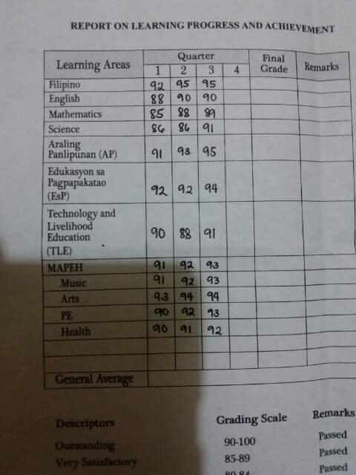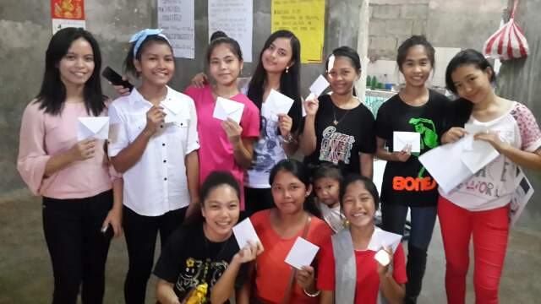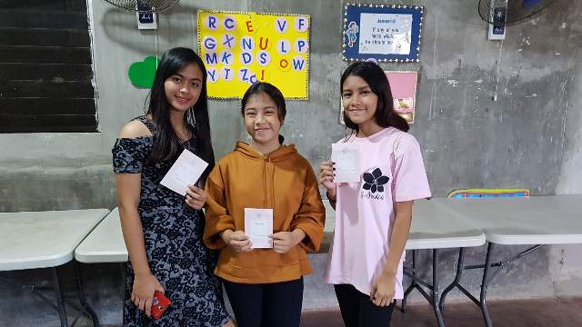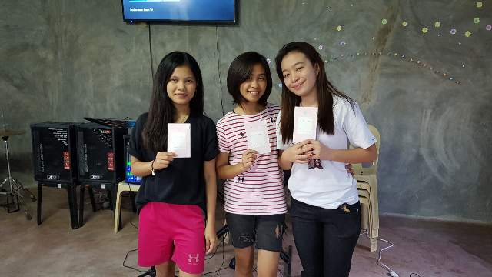

**Report card (Philippines)**

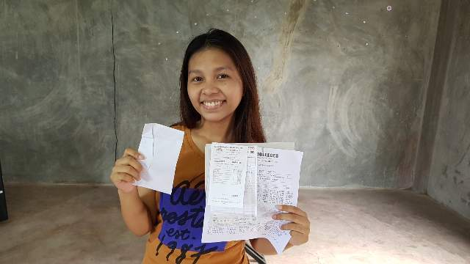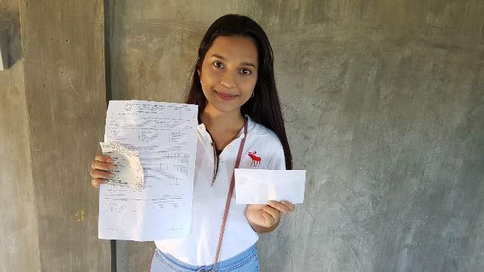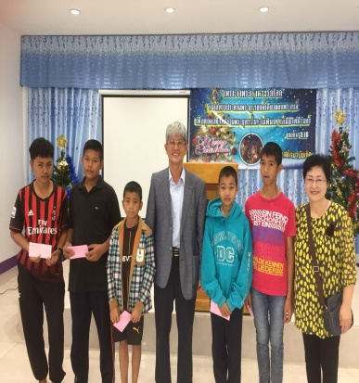

**Angell Mary yol Charlot (Thailand)**

1. **Homeless Sharing Ministry**

**Many people live in homelessness in Los Angeles, USA (between 45,000 and 100,000 estimates)**

**TENT MAKERS MISSION serves the mission field for 6 months a year. While staying in Los Angeles, we serve homeless people with simple yogi, life necessities and cosmetics.**

**We are trying to share the encouragement and love of Jesus with those who pray for those who do not have a place to worship for a while.**

**It is also challenging for us to see that they serve the Lord in their hearts without losing their faith in their depressed environment.**

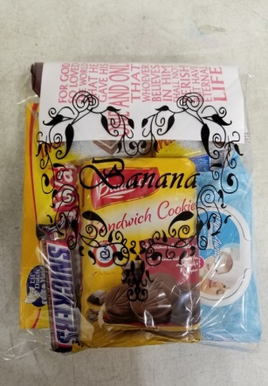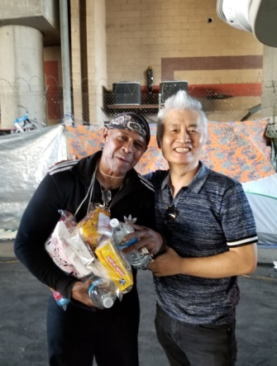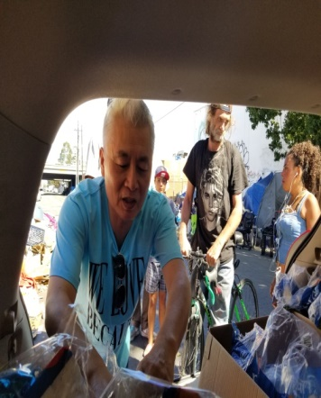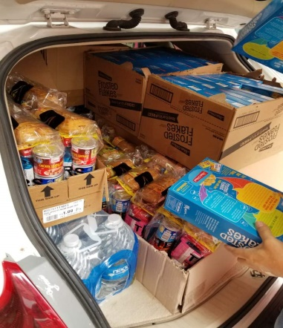

**6. Missionary Bible Study Supply and Korean Children's Support Ministry**

**- I heard that Bible books purchased in mission fields are usually expensive. We are distributing Bible books to such countries. We are working to supply biblical books and to make the Word a living.**

**In addition, there are many people who serve mission fields with various items as well as children's hanbok.**

**TENT MAKERS MISSION is not able to visit the mission field directly, but we also visit our mission field with the heart of our faith partners who want to serve with various goods.**

**(In some cases, logistics costs are cheaper.)**

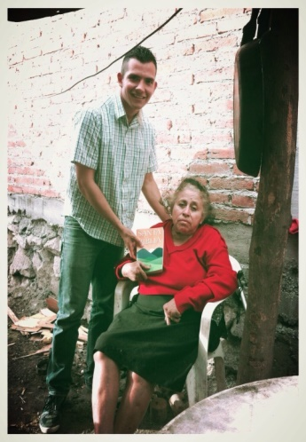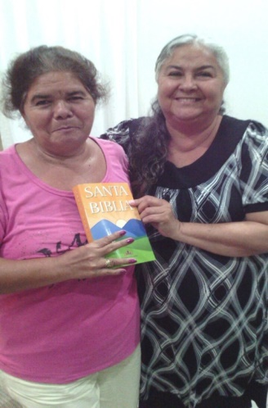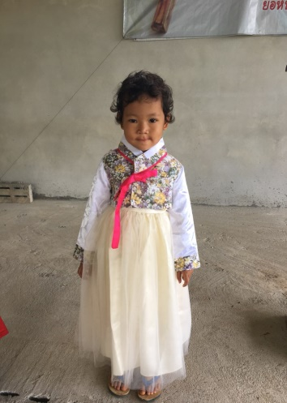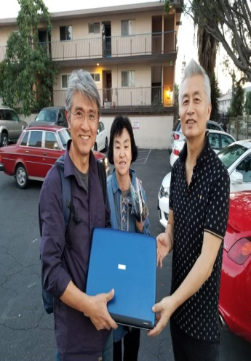

**여기 동영상을 확인해 보세요** [**https://youtu.be/n2L3bJfhCoA**](https://youtu.be/n2L3bJfhCoA)